# ==========================================================
# 1. BAYES THEOREM
# ==========================================================

print("1. BAYES THEOREM")
print("-" * 50)

# Imagine 100 people take a disease test
total_people = 100

# 10 people actually have the disease
diseased_people = 10

# Among the 10 diseased people, 9 test positive
sick_and_positive = 9

# Among the 90 healthy people, 9 wrongly test positive
healthy_and_positive = 9

# Total positive test results
total_positive = sick_and_positive + healthy_and_positive

# Bayes result:
# Actual sick positive people / All positive people
posterior_probability = sick_and_positive / total_positive

print("Total people:", total_people)
print("People with disease:", diseased_people)
print("Sick people who tested positive:", sick_and_positive)
print("Healthy people who tested positive:", healthy_and_positive)
print("Total positive results:", total_positive)

print(
"Probability of disease after positive test:",
posterior_probability * 100,
"%"
)
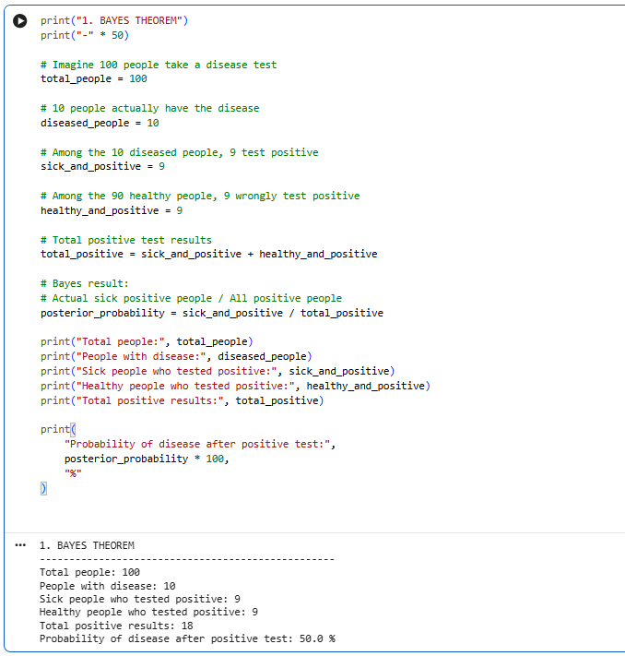

# ==========================================================
# 2. CONCEPT LEARNING USING MAP
# ==========================================================

print("\n2. CONCEPT LEARNING USING MAP")
print("-" * 50)

# Training data:
# Study hours, Attendance, Actual result
# 1 = Pass
# 0 = Fail

students = [
[6, 90, 1],
[6, 60, 0],
[3, 90, 0],
[5, 80, 1],
[2, 40, 0]
]

# Rule 1:
# Student passes when study hours are at least 5
def rule1(study_hours, attendance):
return 1 if study_hours >= 5 else 0

# Rule 2:
# Student passes when attendance is at least 75%
def rule2(study_hours, attendance):
return 1 if attendance >= 75 else 0

# Rule 3:
# Student passes only when both conditions are satisfied
def rule3(study_hours, attendance):
return 1 if study_hours >= 5 and attendance >= 75 else 0

rules = {
"Rule 1: Study hours": rule1,
"Rule 2: Attendance": rule2,
"Rule 3: Study hours and attendance": rule3
}

# All rules initially have equal prior probability
prior_probability = 1 / 3

best_rule = None
highest_map_score = -1

for rule_name, rule_function in rules.items():

correct_predictions = 0

for study_hours, attendance, actual_result in students:

predicted_result = rule_function(
study_hours,
attendance
)

if predicted_result == actual_result:
correct_predictions += 1

# Likelihood = correct predictions / total examples
likelihood = correct_predictions / len(students)

# MAP score = Likelihood × Prior
map_score = likelihood * prior_probability

print("\n", rule_name)
print("Correct predictions:", correct_predictions, "out of", len(students))
print("Likelihood:", round(likelihood, 2))
print("Prior:", round(prior_probability, 2))
print("MAP score:", round(map_score, 4))

if map_score > highest_map_score:
highest_map_score = map_score
best_rule = rule_name

print("\nBest rule selected by the machine:")
print(best_rule)
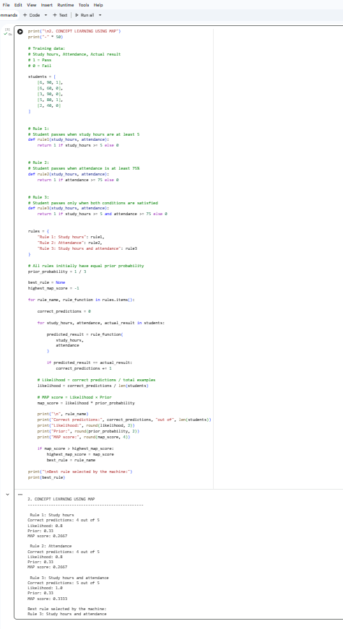

# ==========================================================
# 3. MAXIMUM LIKELIHOOD
# ==========================================================

print("\n3. MAXIMUM LIKELIHOOD")
print("-" * 50)

# Actual student marks
actual_marks = [50, 60, 70]

# Predictions from two different models
model1_predictions = [49, 61, 69]
model2_predictions = [30, 80, 90]

# Function to calculate squared prediction error
def squared_error(actual, predicted):

total_error = 0

for actual_value, predicted_value in zip(actual, predicted):

error = actual_value - predicted_value
total_error += error ** 2

return total_error

model1_error = squared_error(
actual_marks,
model1_predictions
)

model2_error = squared_error(
actual_marks,
model2_predictions
)

print("Actual marks:", actual_marks)

print("\nModel 1 predictions:", model1_predictions)
print("Model 1 squared error:", model1_error)

print("\nModel 2 predictions:", model2_predictions)
print("Model 2 squared error:", model2_error)

# Smaller error means greater likelihood
if model1_error < model2_error:
selected_model = "Model 1"
else:
selected_model = "Model 2"

print("\nMaximum Likelihood selects:", selected_model)
